**Ai Stylist**

**1.User interface**

The AI ​​Stylist user interface (UI) is designed to provide a seamless and engaging experience for users. Featuring a simple and easy-to-interface design, the site offers personalized fashion recommendations based on user preferences. The interface features clear visual elements, such as clothing images and favorite colors, with easy-to-use buttons for selecting recommended outfits. It also allows users to adjust their preferences and select their favorite styles to further customize their experience.

**1.1 Home page**: shows the homepage of an app that provides fashion advice using artificial intelligence. The app includes three main features:

1. Personal Analysis: Provides accurate analysis of the user's style and assessments.
2. custom Recommendations: Offers suitable clothing based on body shape and personal taste.
3. Smart Shopping: Provides suggestions from multiple sources that fit the user's budget.

The goal is to help them discover their unique style with ease.

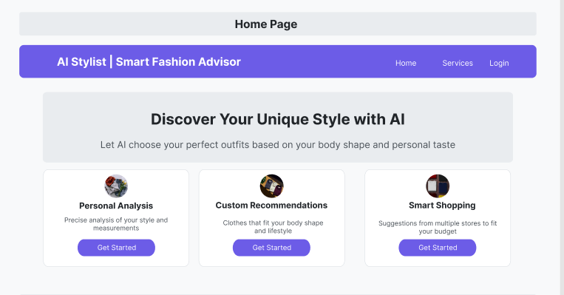

Figure 1Home Page (figma)

**1.2 Personal analysis page**: shows the user personality analysis interface of the "AI Stylist | Smart Fashion Advisor" app. The design includes a box for uploading a user's photo, where users can drag and drop the image or click the "Upload Image" option to upload it. Questions are asked to conduct a comprehensive personal style analysis, such as preferred clothing style (casual, formal, sporty, or trendy), favorite colors, as well as height and weight measurements. The bottom section displays a "Continue" button to advance to the next stage of the process. This interface serves as a starting point for understanding individual preferences and providing appropriate fashion advice.

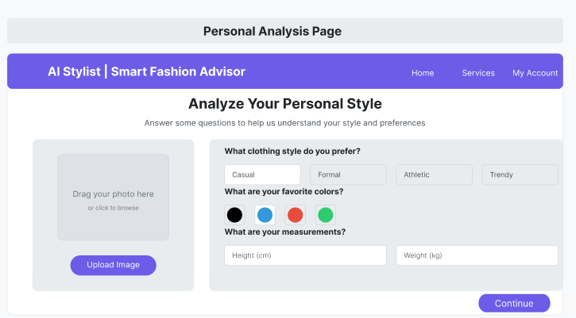

Figure 2 Personal Analysis page (figma)

**1.3 Recommendation page** : Filtering option: Users can filter recommendations based on price, color, or season. Suggested clothing collections: Casual Work Collection: A casual collection suitable for work, with the option to view details. Formal Event Outfits: Formal attire suitable for events, with additional details. Modern Athletic Style: Outfits that combine comfort and style, with the option to view details

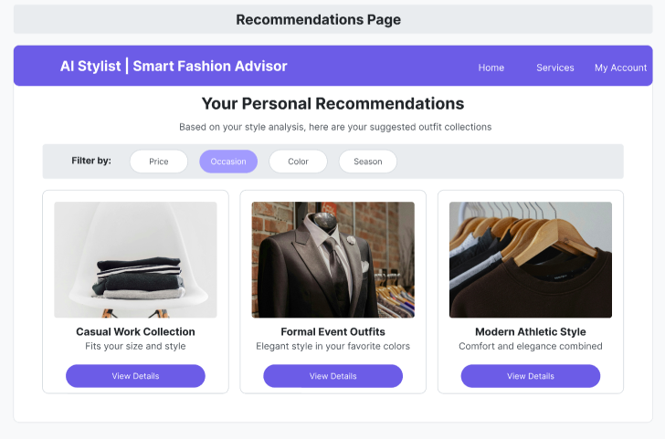

Figure 3 Recommendations page (figma)